The Structure of the Earth

Chart numbering: The charts are originally numbered as they were in my training, and I’ve also added the corresponding numbering for the “Montessori For Everyone” charts (MFE) when available.

Original impressionistic (hand-drawn) chart: Purchase here
Montessori For Everyone (realistic) charts: Purchase here

Notes:

- Follow your child’s interests. It is suggested that you present this lesson right after the Nature of the Elements experiments and before the Sun and the Earth story (but you can also reverse the order of Nature of Elements and Structure of the Earth). Then, we’ll revisit these concepts more in-depth as the children get older.
- To get children engaged in this lesson, you might want to start by letting them re-do the oil/water/honey experiment from the first Great Story.

PRESENTATION: (given as a conversation/guided exploration of the chart)

In the story of “The Origin of the Universe”, do you remember when we spoke about how when it got hot things expanded and when things got cold they would shrink and fall, just like a grain of sand falls to the bottom of a pond. Because of this law, the Earth gradually changed from a ball of fire to the Earth we have now. This was the law that the particles obeyed while they danced.

These particles were so small that we cannot see them, but there were so many of them that together they made the whole world. We spoke about how this dance went on for millions of years, until the particles settled down like tired dancers.

We did an experiment about how they settled down (oil, water, and honey experiment). Let the children re-do the experiment if they need something hands-on to do to engage with the lesson.

Some of them became liquid and then solid, joining others like themselves. The heavier ones sank and went closer to the heart of the earth, while the lighter ones floated on top (just like the oil floated on water). As the Earth cooled down, the particles settled according to weight.
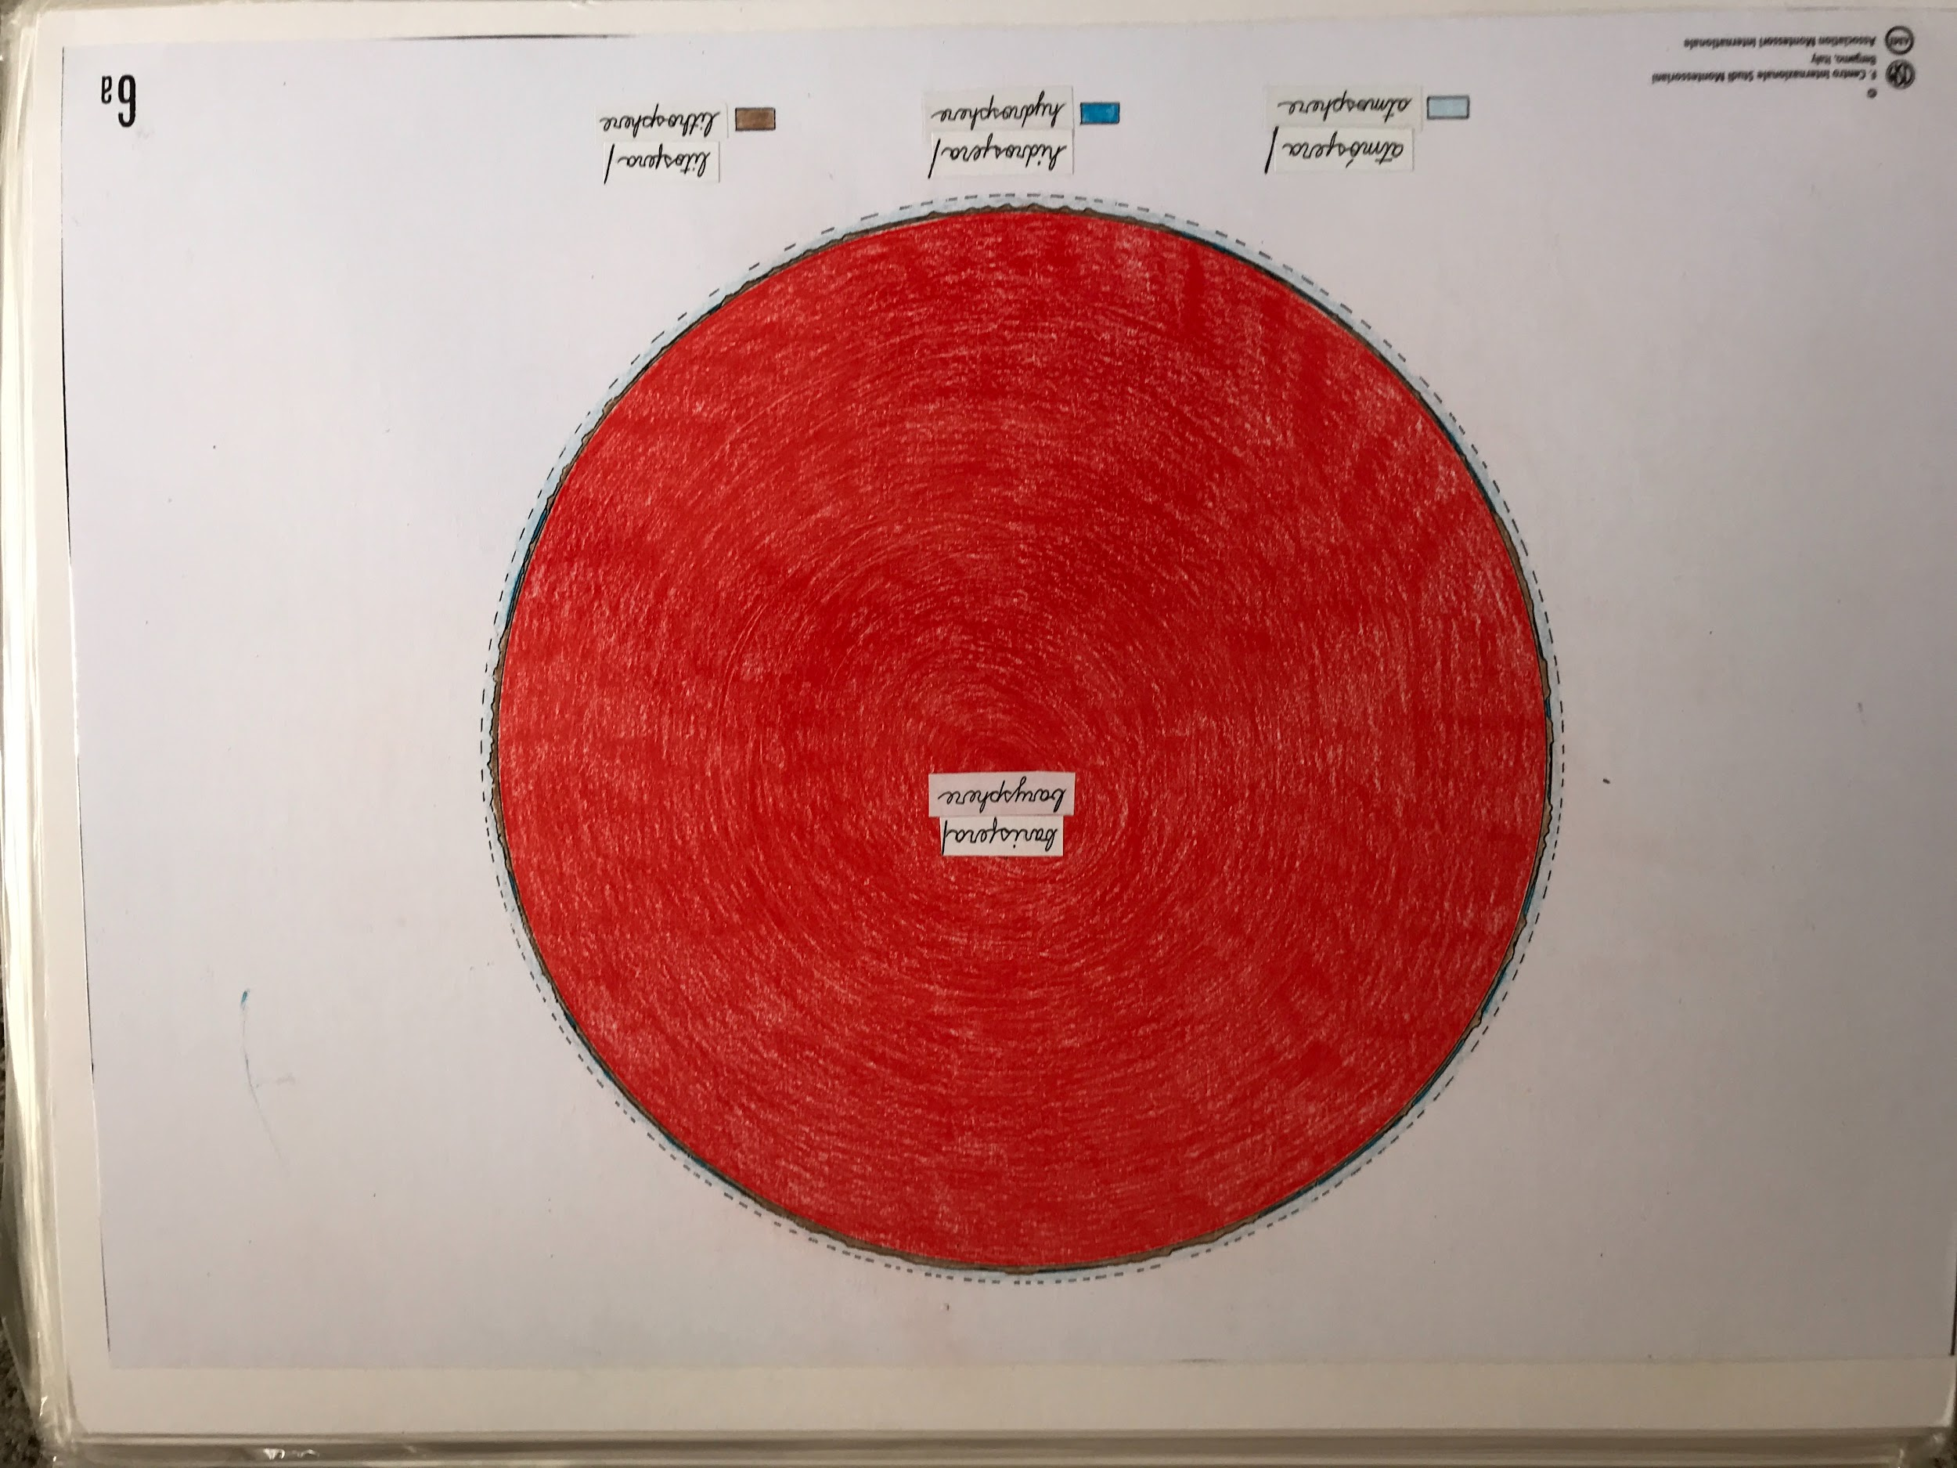
- Show chart #6a/MFE 6
The part of the Earth that is colored red is the barysphere. Bary is a Greek word meaning “heavy”.

Above the barysphere, what is colored in brown, is the lithosphere. Lithos means “stone”, it is also a Greek word. It is the part on which we live.

In the holes and crevices of the lithosphere is another layer; the hydrosphere. Hydro is also a Greek word, meaning “water”. This is where we find the oceans of the Earth.

Surrounding all of this we find the atmosphere. Atmos comes from Greek and means “vapor”. The atmosphere is the lightest layer of them all. We need this layer to live because this is the air we breathe.

Etymology:
- barys = heavy
- lithos = stone
- hydro = water
- atmos = vapor
Close-up of the chart (for adults preparing for the lesson):
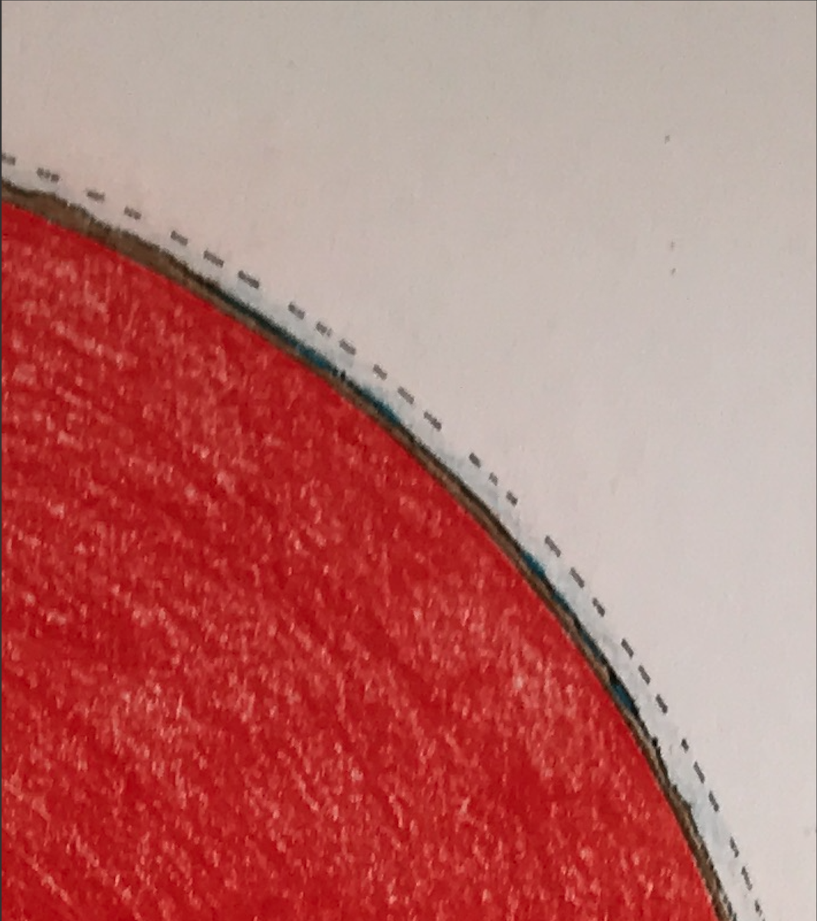

Let’s compare the different layers. Compared to the rest of the Earth, the lithosphere on which we live seems very thin. The diameter of the Earth is about 8,000 miles. The lithosphere’s thickness varies from a couple of kms up to 70 kms. However, one usually says an average of about 20 miles (32 kms) thick. The depth of the hydrosphere is 2.5 miles (4kms). The thickness of the atmosphere is about 200 miles (322 kms). We live in the lower part of the atmosphere, where the atmosphere is breathable. (Note: We do not expect the children to do anything with this information right now._

Optional exploration: We bring a meter stick out and show that we can make a scale where 1 meter = 1,000 miles. Therefore, the Earth’s diameter = 8 meter sticks. Make comparisons with the children, to find out that the atmosphere = 1/5 of a meter stick (20 cm.). The lithosphere = 0.02 of the meter stick. The hydrosphere = 2.5 mm. You can leave the children to figure out the scale of the barysphere.

Next steps:

Gravity: This can be an interesting exploration (find the lessons here), since gravity is what allowed the particles to settle and created the conditions necessary for life. Remember, we’re just planting seeds so there’s no need to go into very scientific explanations with young elementary children.

Layers of the Earth: Now that the children have an understanding of the Earth as a whole, you can zoom in and explore the layers of the Earth (crust, mantle, outer core, inner core). You can find a series of materials here. (Note: The Montessori For Everyone chart already shows the layers of the Earth).

- Spanish version (from a different vendor) here.

Volcano: You can use nomenclature cards to help the children learn about the parts of a volcano now that they understand the structure of the Earth. (Note: if using the cards from the link, print two copies so you can use one as the matching material and the other as the control booklet.)

